|  |
| --- |
| **OXFORD INTERNATIONAL SCHOOL**  **Pre Exam 2023-24**  **Name: _____________ Grade: VII Subject: Mathematics. /50** |

**Q1 (a): Multiple Choice Questions. /10**

1. 6x = 60 a. 6 b. 1 c. -5 d. 25
2. Gradient =

$\frac{vertical change }{horizontal change}$ ______
3. b. $\frac{rise }{run}$ c. both a and b d. axis
4. _______ is a measure of how steep a slope is.
5. Horizontal b. Vertical c. both d. Gradient
6. Sin A = $\frac{opposite }{hypotenouse}$ = _____
7. Sin b. $\frac{perpendicular}{base}$ c. $\frac{perpendicualr}{hypotenouse }$ d. both a and b
8. Sin A = $\frac{opposite}{adjacent}$ = _____
9. Both b and c b. perpendicular c. $\frac{perpendicular}{base}$ d. finite
10. A pentagon has ______ sides. a. 5 b. 4 c. 3 d. 1
11. In a ________, the apex is the vertex at the "top" (opposite the base)
12. Sphere b. Pyramid c. Rectangle d. Triangle
13. Total surface area of Pyramid = ___________
14. Total volume b. total area of all faces c. both a and b d. sphere
15. A shape or an object has _________ if it can be divided into two identical pieces.
16. Symmetry b. area c. mirror d. lines
17. € is a symbol which means ________. If bB, it shows that b is the element of B
18. Not belongs to b. ‘belongs to’ c. U d. Ո

**Q1 (b): Fill in the blanks. /5**

1. The formula of Mean = _____
2. Volume of Cylinder = ______
3. Volume of Pyramid = ______
4. Y-axis is always be _______
5. Volume of Sphere = _______
6. The line that slopes upwards from left to right its gradient is ______
7. Three ratios are known as _____ ratios.
8. In Mathematics, we use the term ‘set’ to describe any collection of _____ and ______ objects.
9. A’ = ____
10. The area of triangle is ______ (formula)

**Q2: Given that the equation of the line representing each of the following linear graphs is in the form Y= mx+c, find the gradient m and state the y-intercepts. /5**

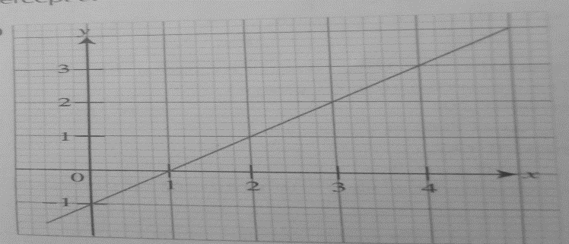 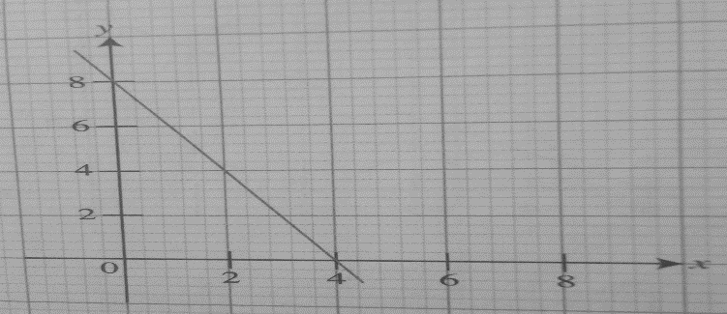

**Q3: Use calculator to evaluate each of the following. /3 a. $\frac{5 tan {61.4}^{o}}{2cos{10.3}^{0}}$ b. $\frac{4 (sin {22.5}^{o})\frac{2}{}}{cos67.5^{0}}$**

**Q4: Find the value of unknown in each of the following right-angled triangle. /3**

1. 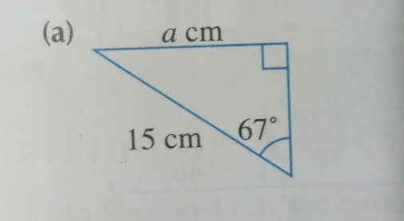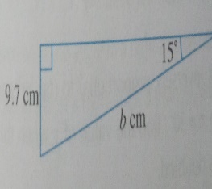 **b.**

**Q5: OABCDEF is hexagonal Pyramid with a base area of 23 cm2 and a height of 6cm find the Pyramid.** **/5**

1. 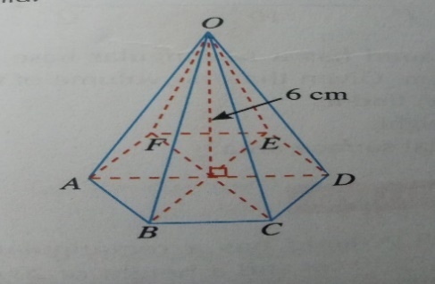

**/5**

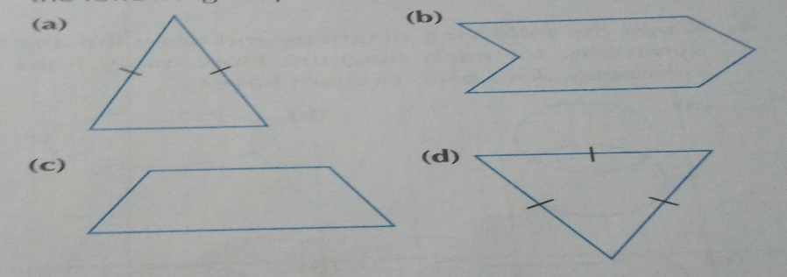**Q6. How many lines of symmetry are there in each of the following shapes? /4**

**Q7. List the element of the following sets. /5**

1. **{vowels in the word “MATHEMATICS”}**
2. **{The seven colors of rainbow}**
3. **{Multiples of 9 which are less than 50)**
4. **{Colors in your school flag}**
5. **{Even numbers which are between 10 and 23}**

**Q8. The number of days the students in a class were absent from school in a term was recorded. /5**

|  |  |  |  |  |  |  |  |  |
| --- | --- | --- | --- | --- | --- | --- | --- | --- |
| **Number of days absent.** | **0** | **1** | **2** | **3** | **4** | **5** | **6** | **9** |
| **Number of students** | **23** | **4** | **5** | **2** | **2** | **1** | **2** | **1** |

**Find the mean number of days of absence.**

**Q9: Solve the given word problems. /5**

1. **A cone has a height of 14cm and a volume of 132cm3. Find the radius of the circular base. (Take π to be $\frac{22}{7}$**
2. **The volume of cone with a circular base of radius 8cm is 320cm3 . Find its height.**
3. **A cone has a base area of 20 m2 and a volume of 160cm3. Find the height of the cone.**
4. **A cone has a circular base of radius 3m and a height of 4m. Find the curved surface area of cone.**